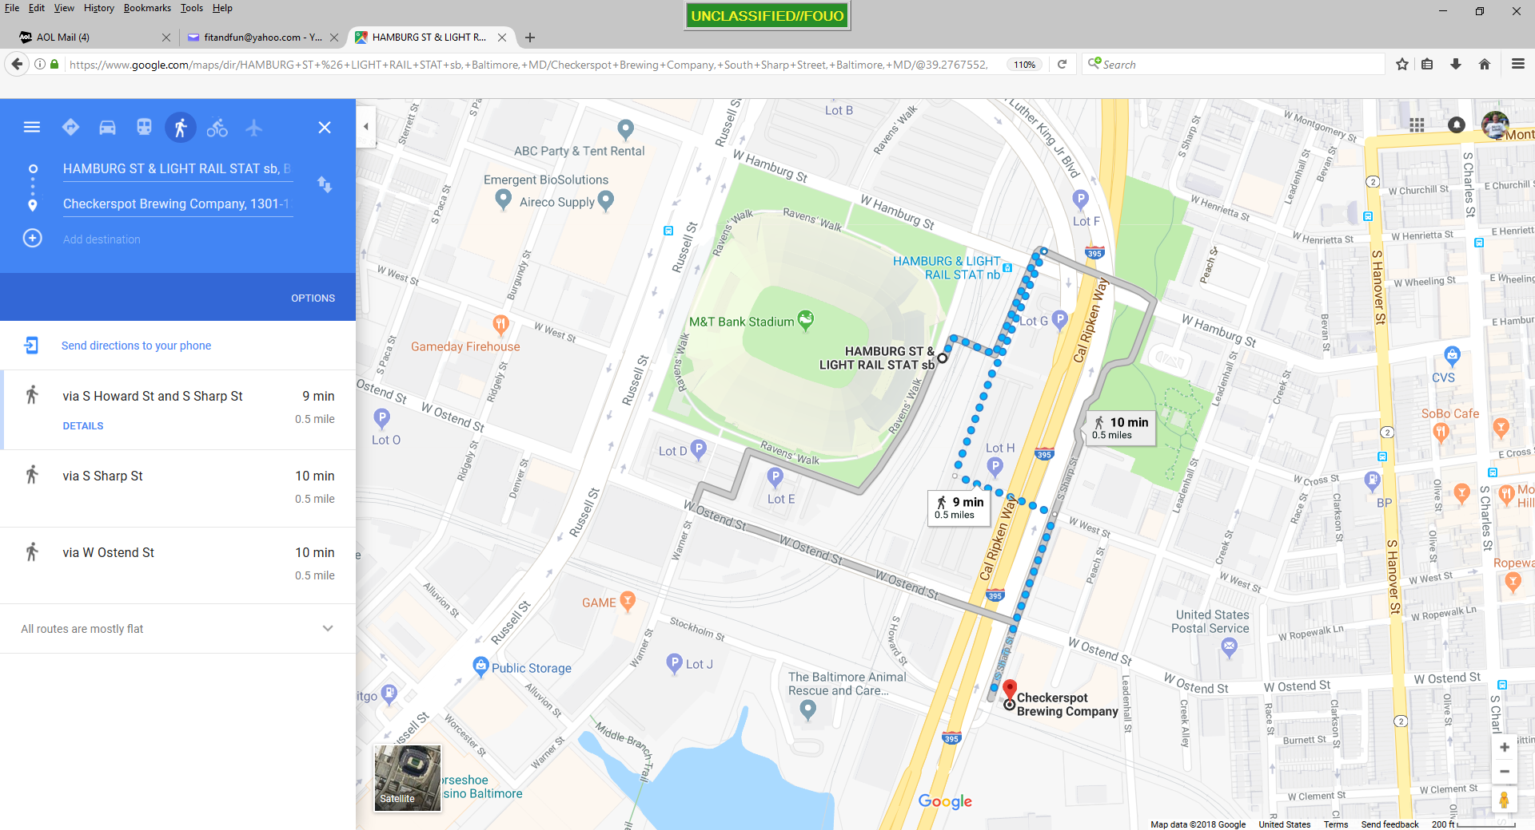

Hamburg St Light Rail

to

Checkerspot

1399 Sharp St.

West St

Sharp St

Howard St

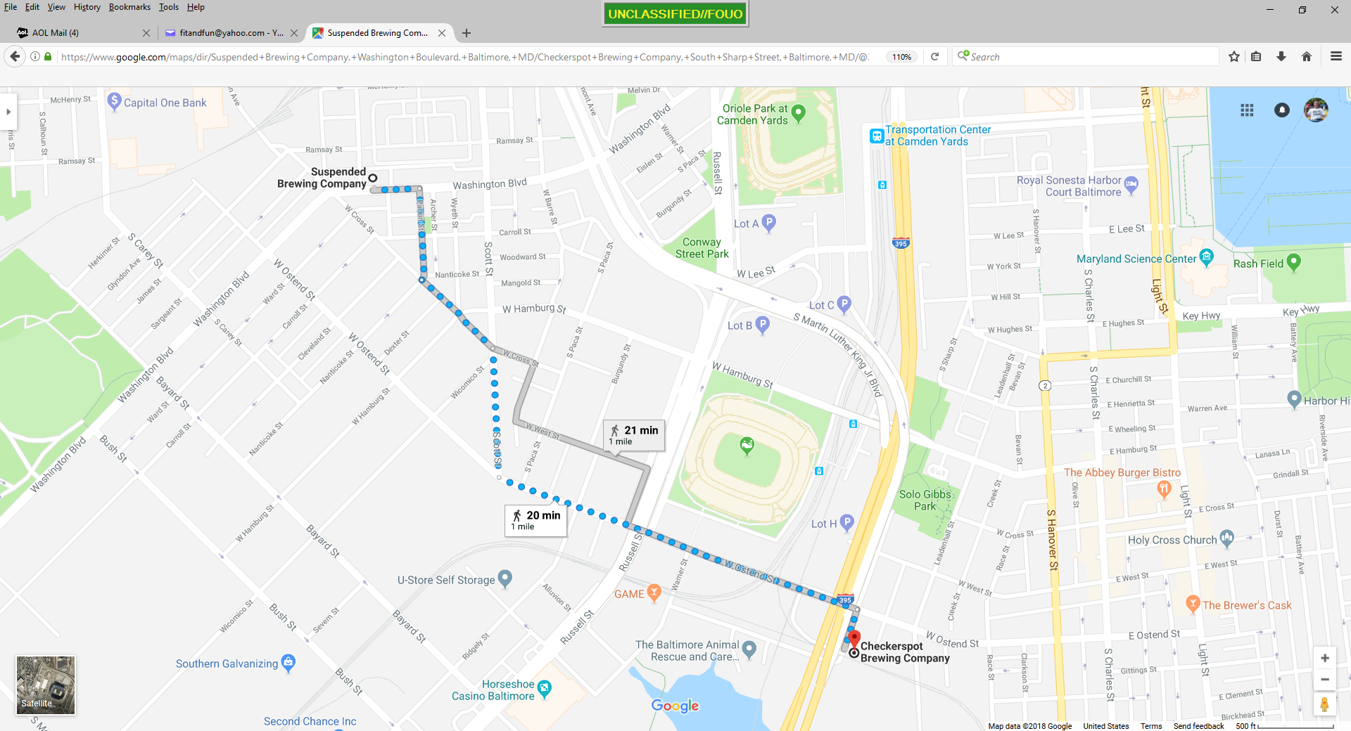

Checkerspot

to

Suspended

912 Washington Blvd

Sharp St

Ostend St

Scott St

Cross St

Parkin St

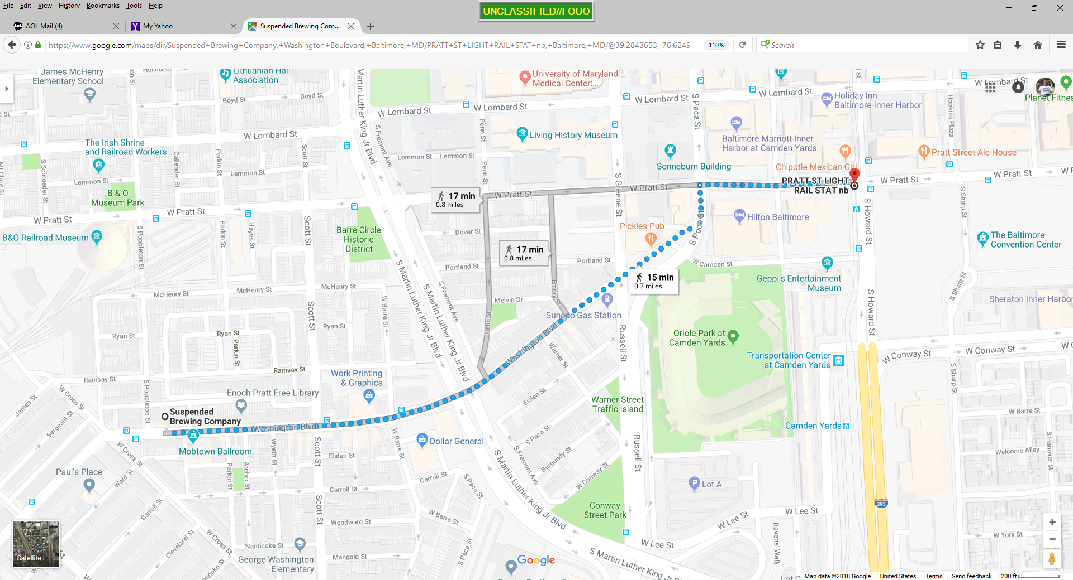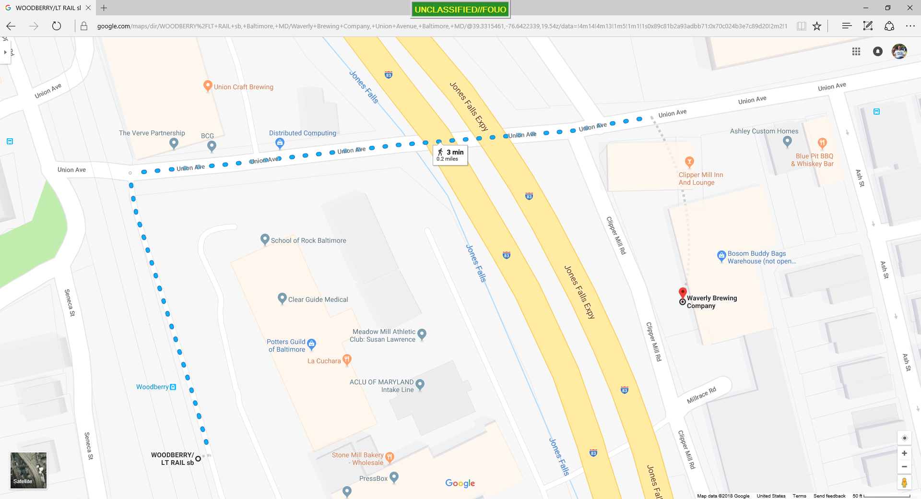

Suspended

to

Pratt St Light Rail

Paca St

Washington Blvd

Washington Blvd

Clipper Mill Rd

Union Ave

Woodberry Light Rail

to

Waverly/Union

Waverly

Union Craft Brewing

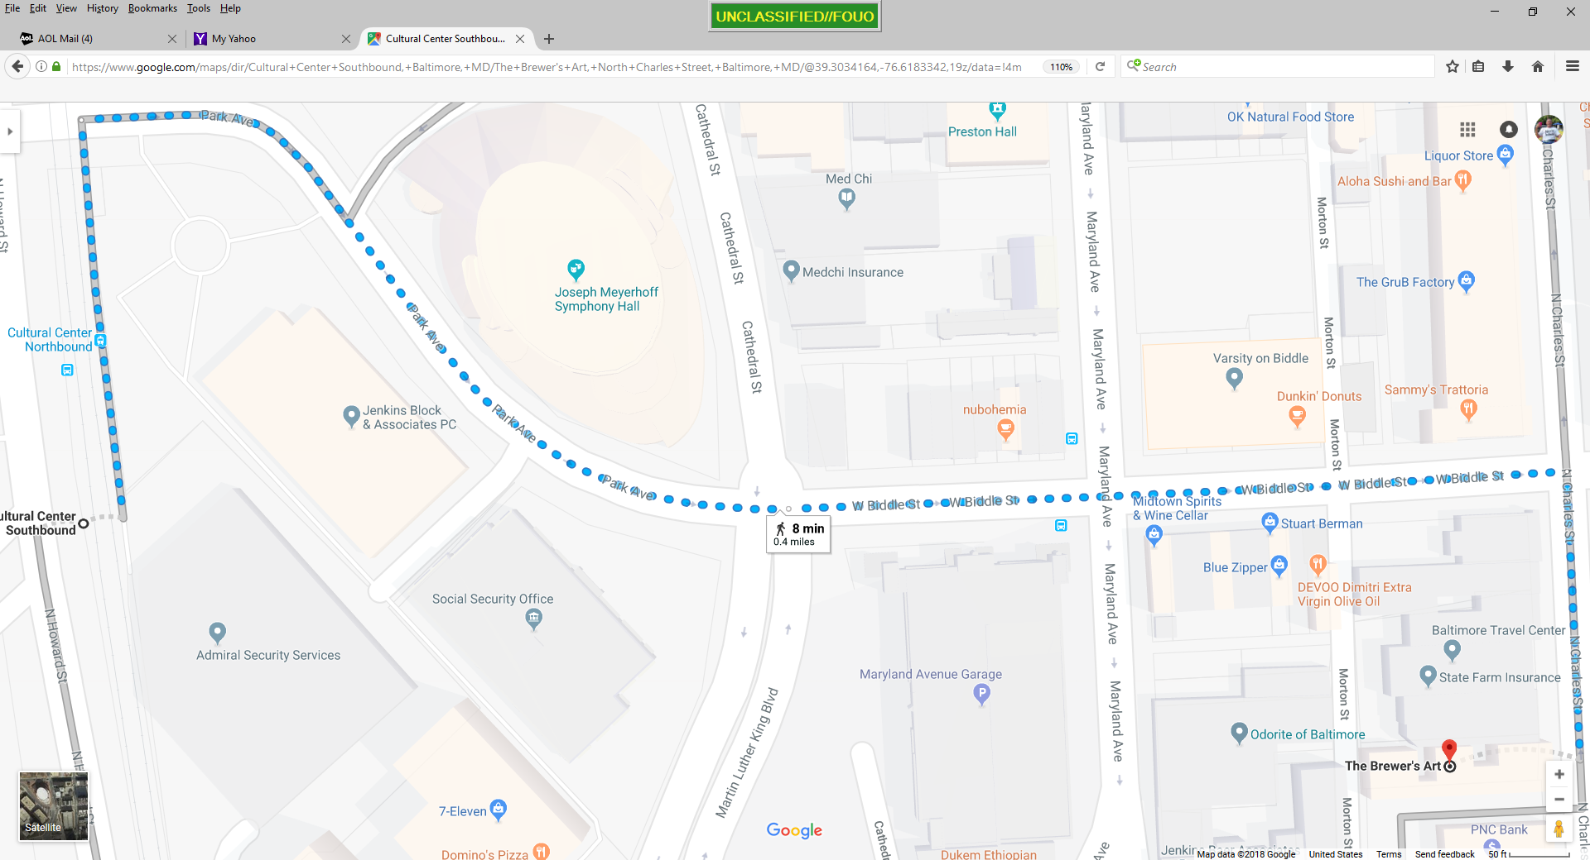

Charles St

Biddle St

Park Ave

Park Ave

Cultural Center Light Rail

to

Brewer’s Art